Name_____________
Chapter 1 Note Taking Guide:
1.1 MARKET ECONOMIES

Our businesses operate in a _________________ marketplace and deal with a variety of ________________ __________________ that influence each other.

__________________ take different approaches in how their economies operate, but each must provide answers to the same basic economic questions

Economic Problem
Scarcity _______________________________________________________________________

______________________________________________________________________________

Key Economic Questions
1. __________________________________________?

2. __________________________________________?

3. __________________________________________?

Types of Economic Systems:
  - ___________ Economy _________________________________

  - ___________ Economy _________________________________

  - ___________ Economy

Market Economy ________________________________________________________________

______________________________________________________________________________

Capitalism _____________________________________________________________________

______________________________________________________________________________

Characteristics of Market Economies
Private enterprise _______________________________________________________________

______________________________________________________________________________

Private property ________________________________________________________________

______________________________________________________________________________

Profit _________________________________________________________________________

______________________________________________________________________________

Competition ___________________________________________________________________

______________________________________________________________________________

  - MAKE DECISIONS
Needs ________________________________________________________________________
______________________________________________________________________________

Wants ________________________________________________________________________

______________________________________________________________________________

Goods ________________________________________________________________________

______________________________________________________________________________

Services _______________________________________________________________________

______________________________________________________________________________

Economic Resources _____________________________________________________________

______________________________________________________________________________

There are three kinds of economic resources:
- _______________
- _______________
- _______________

Economic Decision Making
Decision-making ________________________________________________________________

______________________________________________________________________________
1
2
3
4
6
5

1.3 HEALTHY ECONOMIES

Economic Measurements
Three measurements used in looking at the health of an economy are:

Gross domestic product (GDP) _____________________________________________________

______________________________________________________________________________
It is a basic _________________ of how an economy is doing.

GDP Includes Four Major Categories
- _________________ spending for ___________________________________________
- _________________ spending for ___________________________________________
- _________________ spending for ___________________________________________
- The _______________ of a country less the _________________ of the country

Labor Productivity _______________________________________________________________

______________________________________________________________________________

Productivity Model = _________________________ / ______________________

Inflation _______________________________________________________________________

______________________________________________________________________________

Deflation ______________________________________________________________________

______________________________________________________________________________

Business cycle __________________________________________________________________

______________________________________________________________________________

Four phases:
Prosperity: is the phase where most people who want to work are _______________ and businesses produce goods and services in ______________________.

Recession is a phase of the business cycle where demand for goods and services begins to ___________, production ________________, unemployment begins to _________, and GDP growth ____________________.

Depression is a phase of the business cycle marked by a prolonged period of ________________, weak _____________ of goods and services, and business _________________.

Recovery is the phase in which _______________________________ begins to _________, demand for goods and services begins to ______________, and GDP begins to ___________ ________.
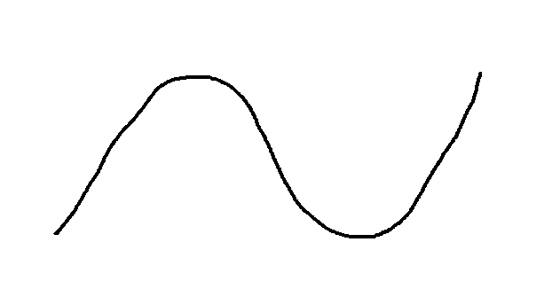
1.4 PARTICIPATE IN AN ECONOMY
Economic Roles
Citizen ________________________________________________________________________

_____________________________________________________________________________________

Worker _______________________________________________________________________

______________________________________________________________________________

Consumer _____________________________________________________________________

______________________________________________________________________________

Supply and Demand
Demand is the relationship between the amount of a _______________________ that consumers are ______________________________ and the price of the _______________________.

Supply is the amount of a good or service that __________________ are willing and able to provide and the ______________ of the good or service.

Supply and Demand Effect on Price
Demand
As the demand for a good or service increases, the price tends to go up.
As demand begins to fall, the price generally goes down.

Supply
When a product is in short supply, prices tend to increase if the demand stays the same.

Your Economic Well-Being
Standard of living refers to the way you live as _________________ by the kind and ___________ of goods and services you can _____________.

Quality of life is the _________________ and _________________ that you get from your _______.

