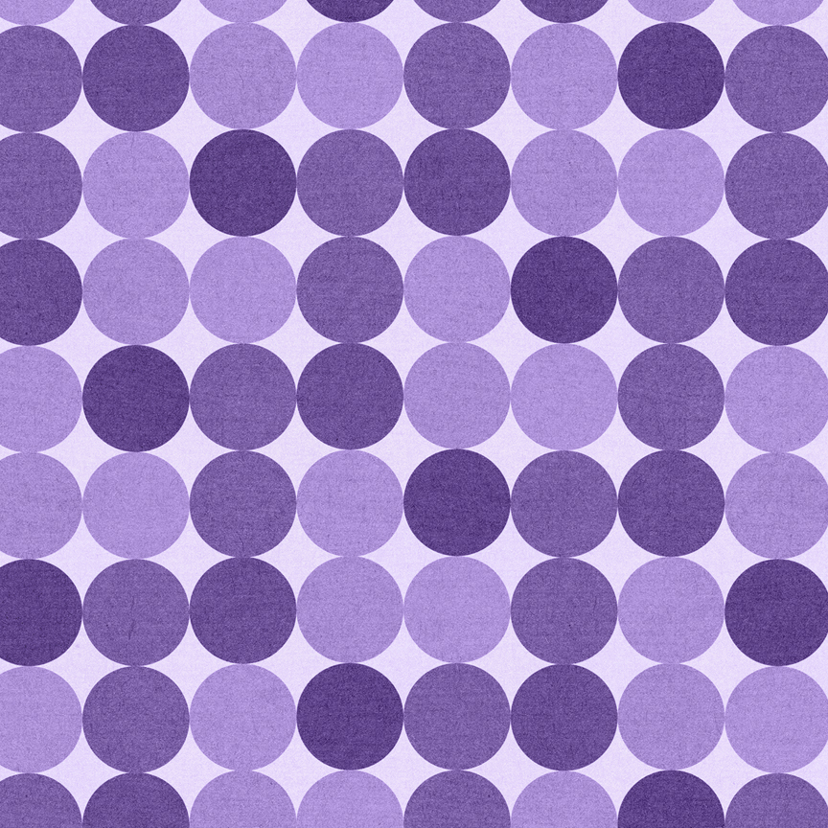

Microsoft Word 2019

*Lesson 2 Application*

|  |  |  |  |  |  |  |  |
| --- | --- | --- | --- | --- | --- | --- | --- |
| **I Can…** | | | | | | | |
| **Part A – Page Features** | | **Part B – Text vs. Images** | | **Part C – Text Features** | |  | **Part D – Image Features** |
|  | Page Number |  | Wrap Text |  | Numbering/Outline |  | Image Size |
|  | Filename |  | Text Effects |  | Format Painter |  | Horizontal Line |
|  | Footer Spacing |  | WordArt |  | Hyperlinks |  | 3-D Models |
|  | Watermark |  | Paragraph vs. Text Box |  | Screen Tips |  | SmartArt |
|  | Page Break |  | Page Border |  | Change Case |  |  |
|  |  |  | Symbols/Icons |  | Clipboard |  |  |

**Instructions:**

*\*Note – You may follow this exactly, or you can look at the example at the end of the directions and try to figure it out on your own. If you do the second option, still scan the directions and make sure you got everything!*

|  |  |  |  |
| --- | --- | --- | --- |
|  | **Save** – Save this file in your folder with your initials in the file name. | | |
|  | **Margins** – Change the margins to narrow. | | |
|  | **Page Numbering –** Add page numbering on the bottom left corner. | | |
|  | **Footer** – tab over and add a your name and period in the center section. | | |
|  | **File Name** – tab over and insert the file name on the far right side. | | |
|  | **Footer Spacing** – move the footer down to .2. | | |
|  | **Page Border** – Add a thin line page border, ½ inch. Make it blue. | | |
|  | **Font Size – Do CTRL+A and change the font size to size 10. DO NOT MISS THIS STEP or it will be hard to fix later!** | | |
|  | **Change Case** – enter the Header and type “Gorman Institute.” Change the font to size to 16, and make it all caps. | | |
|  | **Text Effects** – Change the text effects on it to Fill, Text Color 1, Shadow. Add a 5pt blue glow. | | |
|  | **Resize image** - Insert the image “Gorman Letterhead Logo” from your folder. Resize it to a height of .75. | | |
|  | Below Gorman institute, type in the address: 560 W. Broadway, Springwood, Oklahoma. (make sure to remove formatting so it’s back to Calibri font.) | | |
|  | **Symbols** - Press enter and add the symbol #42 from Wingdings. Then type “Clarence.gorman@gormaninst.com.” Ensure that the email has a hyperlink. | | |
|  | Press tab and do symbol #40 from Wingdings. Tab, and do symbol #58 from Wingdings. Type “www.gormaninstitute.org.” Ensure that it has a hyperlink. | | |
|  | **Horizontal Line** - Below the address line, add a horizontal line, Blue, Accent 5 Darker 50%, 5pt. | | |
|  | When complete, the header should look like this:    Exit the header. | | |
|  | **Change Case** - Select “January News.” Change the font size to 22 and change it to all caps. | | |
|  | **Paragraph Border** – Add a shade of Blue, Accent 5, lighter 80%. Add a dotted border to the January title. | | |
|  | **Text Effects** – Select “New Mission Graphic”, about six lines down. Add the text effect style Fill, Black, text color 1, shadow. | | |
|  | **Shading** – Add a shade of Blue, Accent 5, Lighter 80%. It should shade all the way across the page. (If it doesn’t, it’s because you did not select the space next to the word *Graphic*. | | |
|  | **Format Painter** – With this title selected, format paint it to the following titles throughout the document: HIPAA Rules Reminder, Introducing New Hires, New Facility Announced!, The Story of Elephants | | |
|  | **Clipboard** – Open your clipboard and clear it. Then select “New Mission Graphic” and the short paragraph below it and cut. See it appear on your clipboard. Do the same with “HIPAA Rules Reminder” and the list below it. | | |
|  | **Paste** – Place your cursor in front of the words “New Facility announced” and use your clipboard to paste the New Mission Graphic section. | | |
|  | Place your cursor in the same place—New Facility announced” and paste the HIPAA section. | | |
|  | **Insert Image** – Place your cursor in front of “Dr. Harriet Stout” in the first section. Insert an image from online—find a picture of a woman that is like a headshot. I typed in “professional headshot” to find a good one. (note—you may need to delete the text box with a caption in it in order to resize!) | | |
|  | **Image Size** – Change the height to 1” (it’s ok if you have fudge it a little to make it fit correctly!) | | |
|  | **Wrap text** – Wrap the text to Tight. Adjust the image to fit on the left side of the paragraph. | | |
|  | Do the same for Dr. Brad Danfer – finding a professional man’s image. Then for Whitney Green. Make sure each of them is re-sized to 1” height and tight wrapping. | | |
|  | **Text Effects** – Select “Dr. Harriet Stout, Phd – Psychiatrist”. Change the text to Uppercase, the same text effect style you’ve been using (black, text color 1). Add a blue glow to it. | | |
|  | **Format Painter** – Format paint this same style to the other two new names. You will have to add Change Case to each individually, as it won’t be picked up by the format painter. | | |
|  | **Horizontal Line** – Add a horizontal line above and below Dr. Brad Danfer. *Make sure to remove any blank lines above or below the line that may appear.* | | |
|  | **Page Break** – Place your cursor before the title “HIPAA Rules Reminder” and add a page break so that it starts on page 2. | | |
|  | **SmartArt** – Create the following SmartArt. Here are some tips to help you figure it out:   * There are two different SmartArts on top of each other. Do the center one first, and make sure to change the wrap to Tight. * For the first one, use Vertical Picture Accent List (select Picture Strips first, then choose the image shown on the right under layouts.) * For the pictures, use icons of a child, an adult (person), and an elderly (person). * You may use any style or color you wish. * For the second one, use Text Cycle. * After typing the information in, change the wrap to tight and place it on top of the other.   **This part is actually shown step by step in the Lesson 2 Video! | | |
|  | **Grouping** – This next part is tricky—you may want to consult the video to get it right. You want the first SmartArt to be on Tight. Change the second to Behind Text. Arrange them as you want them, then select the center one, hold down the ctrl key, and select the larger one. Now they are BOTH highlighted. Right click on the edge and choose “Group”. Now they are one image that moves together. Change the wrap once again to Square. |  | |
|  | **IF the grouping isn’t working –** Grouping is tricky so if you are having a hard time getting it to work, don’t worry about it. Just change the wrap on the 1st Smartart to Square and put it behind text. Place it exactly where you want it, making the edges tight. Then place the other smartart inside it. You can adjust it as needed to fit, they just won’t move together like they would if they were grouped. |
|  | **Resize** – Resize the grouped image to 3.2 and move it so it looks like the example at the bottom of these instructions. |
|  | **Again—if you are having trouble with this part, click on the “DOUBLE SMARTART” section of the video. |
|  | **Outline** – Select the list under HIPAA Rules Reminder and number them. Then use tab to make it look like this: | | |
|  | **3-D Modeling** – In the New Facility section, insert a 3-D model of a building. | | |
|  | Move the image to the far right. Change the **wrap** to Tight and watch how the text interacts with it. You may want to choose Square if it works better. | | |
|  | **Resize** the image to roughly 1.75 to 2 inches, depending on it’s shape and the angle you set it to. | | |
|  | **Italics** – Select the story of the Elephants, ending with the words “beautiful life” and change it to Italics. After the first paragraph, press enter. | | |
|  | **Paste** – Paste this sentence there: “When they are very young and much smaller, we use the same size rope to tie them and, at that age, it’s enough to hold them. As they grow up, they are conditioned to believe they cannot break away. They believe the rope can still hold them, so they never try to break free.” | | |
|  | **Bold** – Bold the sentence you just pasted. | | |
|  | **Paragraph Formatting** – Select the whole story from A Gentleman to Beautiful life. Add the same blue shading and dotted border that you use for the January title. | | |
|  | **Font** – Select “Dr. Clarence Gorman” and change the font to a cursive font and make it larger. | |  |
|  | **Watermark** – Add a picture watermark using the Gorman Logo in your Lesson 2 Folder. | |
|  | **Print** - If you are printing this assignment, print it 2 to 1 page. It should easily fit on two pages. | |

