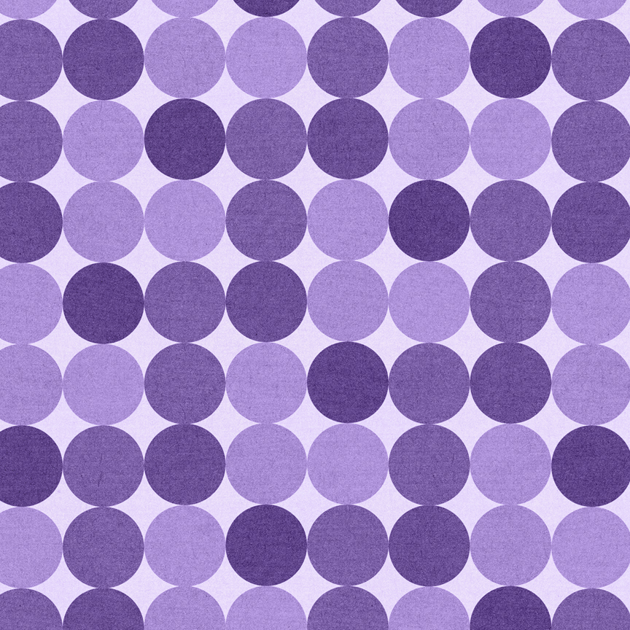

Microsoft Word 2019

*Lesson 2 – Text vs. Images*

|  |  |  |  |  |  |  |  |
| --- | --- | --- | --- | --- | --- | --- | --- |
| **I Can…** | | | | | | | |
| **Part A – Page Features** | | **Part B – Text vs. Images** | | **Part C – Text Features** | |  | **Part D – Image Features** |
|  | Page Number |  | Wrap Text |  | Numbering/Outline |  | Image Size |
|  | Filename |  | Text Effects |  | Format Painter |  | Horizontal Line |
|  | Footer Spacing |  | WordArt |  | Hyperlinks |  | 3-D Models |
|  | Watermark |  | Paragraph vs. Text Box |  | Screen Tips |  | SmartArt |
|  | Page Break |  | Page Border |  | Change Case |  |  |
|  |  |  | Symbols/Icons |  | Clipboard |  |  |

**Instructions:**



|  |  |  |  |  |  |
| --- | --- | --- | --- | --- | --- |
| **\*\*Make sure to watch the introduction to this lesson on the video!!**  Feel free to use New Window or Split, as learned in Lesson 1, in order to see your instructions and the practice page at the same time. This is optional. | | | | | |
| **Part A: Page Features** | | | | | |
|  | **Page Numbering –** Add page numbering to the page margins. Choose “Circle right” as your option. | | | | **A-1** |
|  | *If you have not saved this document yet, please do so now, making sure to include your initials in the file name. | | | |
|  | **Footer Filename –** Add a footer with your name and period. Then add the filename on the far right. | | | | **A-2** |
|  | **Footer From Bottom –** Move the footer down so it’s at .3 from the bottom instead of .5. | | | |
|  | **Watermark –** Add a text watermark to this page. Make it say your first and last name in light purple. You will need to select the color from “more colors” to get it. | | | | **A-3** |
|  | **Note – Watermarks show up behind tables, so you won’t see it on the pages with a table where the directions are. That’s ok. | | | |
|  | **Page Break –** Scroll down to the bottom of the instruction section and place your cursor in front of the words “word 2 practice”. Add a page break, so that the work pages now start on a different page than the instructions.(do not just press enter!Watch the video to understand why.) | | | | **A-4** |
|  | Place your cursor in front of the D-3 title and add a page break there as well, so that the 3-D models are on their own page. | | | |
| **Part B: Text vs. Images** | | | | | |
|  | **Wrap Text –** In this section you will learn the four most common uses of wrap text. We will not be going over Through or Square, but they are similar and you are welcome to test them out. | | | | **B-1** |
|  | **In Line with Text -**  In the table, there is a sentence with a red word. You need to figure out which image in the sixth box is part of that word, then drag it into the sentence. Here’s the first one “He is wearing a new JACKET.” Find the image of the jack and move it in front of the “et” in red. | | | |
|  | **Tight –** Click on the image of the cake and change the wrap to tight. Move it anywhere within the paragraph below the word “tight.” Test out the “square” option for wrapping as well—what is the difference? | | | |
|  | **In Front of Text –** Click on the image of the sandcastle and change the wrap to “In front of text.” Move it so it is NEXT to the words In Front of Text. Note how nothing moves. | | | |
|  | **Behind Text –** Select the image of the eggs and change the wrap to Behind Text. You’ll notice it’s pretty hard to pick it up and move it once you’ve changed the wrap. | | | |
|  | **Select** – Go to the Home ribbon, then on the far, far right click on the Select button. Choose select objects. This will allow you to click on any object regardless of text. Move the eggs so they are behind the text in the Behind Text paragraph, and resize it to about the same size of the paragraph.  **Make sure to go back to select and choose Select All when you are done! | | | |
|  | **Text Effects -**  In the table with six boxes, type a name in each box—you can make it up or it can be a celebrity name. | | | | **B-2** |
|  | Change the font of each name. | | | |
|  | In Box 1, make the font color blue, accent 1, darker 25%, and the Glow, 18 pt gray, Accent color 3. *(this is the name of the color in the color pull-down menu. Hover over each color to see the name)* | | | |
|  | In Box 2, make the font color yellow. Add a black outline, 1 pt thick. | | | |
|  | In Box 3, make the font color dark red, add a reflection tight reflection touching. | | | |
|  | In Box 4, keep the font black, but add a shadow, perspective below. | | | |
|  | In Box 5, choose the *preset Fill*: Gold, Accent color 4, Soft Bevel. Then change the font color to green. | | | |
|  | In Box 6, use any combination of the text effects you choose. | | | |
|  | **WordArt –** In the blank area below B-3, create a WordArt using the style Fill: Orange, Accent Color 2, Outline Orange Accent Color 2. Type a random name in it—again, one you make up or a celebrity or something. | | | | **B-3** |
|  | Change the font size to 24, and edit the edges so they are tighter. | | | |
|  | Select the WordArt you just created and copy it, then paste it two times. Put all three in a straight line. | | | |
|  | **WordArt 1 –** On your first one make the text white, the text outline purple, the fill black and the fill outline purple, 3pt. | | | |
|  | **WordArt 2** – On your second one, make sure you have a thicker font (change it if you need to), then add the bevel Riblet and a half-reflection touching. Make the text green and the outline black. | | | |
|  | **WordArt 3** – On your third one, make the font black, add a yellow glow and transform to Slant Down. Remove the text outline. | | | |
|  | **WordArt vs. Text Effects** – Click on your third WordArt and change the wrap to Tight. Move it into the paragraph below. | | | |
|  | Select the first name in your text effects and drag it into the paragraph. | | | |
|  | **Paragraph Border** – In B-4 on the first paragraph, add a shade of Orange, Accent 2, Lighter 40%. | | | | **B-4** |
|  | On the same paragraph, add a double line border, purple, size 1 ½. | | | |
|  | On Paragraph 2, add the shade Gold, Accent 4, lighter 80%, and a triple line border with the middle line being thicker, at size 3 pt, Light Blue. | | | |
|  | On paragraph 3, select the paragraph and then cut it, using Ctrl +X | | | |
|  | **Paragraphs vs. Text Boxes** - Insert a simple text box and paste the content into that box. | | | |
|  | Resize the text box, changing the color and border to match the example. Move it so it looks like the image below. | | | |
|  | **Page Border** – Now create a dotted line border on this page. Make the width 1 ½, purple. You may choose any dotted border pattern you like. (You may have to select “BOX” from the left side of the menu.) | | | |
|  | **Symbols** – in B-5, there is a table that is 8x2. In the second row, insert the symbol using the directions on the first row. | | | | **B-5** |
|  | **Icons** – In B-6, there is a 6x2 table. Insert a different icon of your choice in each box. Change the color of at least three of them. | | | | **B-6** |
|  | Place your cursor in the large, bottom box and go to Icons. Select seven random icons and insert them all at the same time. | | | |
| **Part C– Text Features** | | | | | |
|  | **Numbering** – Select the list of foods under C-1, and add numbering to the list. | | | | **C-1** |
|  | Place your cursor after the word “lettuce” and press enter. Add the following items to the list so you have 10 items: Celery, Strawberries, Tissues. | | Figure B-1 | |
|  | **New List –** Place your cursor on the blank line below “Tissues.” Do not press enter to get there—you don’t want to continue your list. | |
|  | Type a 1. And tab. Make a new list that looks like this: | |
| **Continue Numbering –** Fix the numbering so that Juice continues at #11. Adjust the indents for the lettered items as well. | |
|  | **New List –** In the empty text box, create a new list that looks like figure 2 C-1 on the next page. | | | |
|  | **Format Painter –** Use format painter to paint the C-2 title to look like the C-1 title. | | | | **C-2** |
|  | In the table, on the left you have a language, and on the right you have the same sentence in each language. Use format painter to copy the formatting of the language over to the sentence. | | | |
|  | On the last language, Maori, use format painter to copy the formatting for any of the names you did in B-2, Text Effect. Paste that style to the word “Maori” and to the sentence that goes with it. | | | Figure C-1 |
|  | **Continuous Format Painter** - Go back to the outline you did in the text box in C-1. Select “Page Features.” Bold it, underline, change the font color and the font. Double click the format paint icon and copy the style to 2, 3, and 4. Turn off the format painter. | | |
|  | **Hyperlinks –** In C-3, use the link button to make the word “google” link to Google.com. Do the same for Amazon. | | | **C-3** |
|  | **Screen Tips** – On the shape, type “Random Paragraph”. They hyperlink it to <https://randomwordgenerator.com/paragraph.php> or use http://watchout4snakes.com/wo4snakes/Random/RandomParagraph | | |
|  | Add a screen tip that says “Click here for a new paragraph” | | |
|  | Practice using the CTRL key to make the link work and open the website. | | |
|  | **Remove hyperlink –** Remove the hyperlink on the elephant icon. | | |
|  | **Change Case –** In the table, change the case as indicated. In column 1, change the case in all three rows to Uppercase, and so forth. | | | **C-4** |
|  | **Clipboard –** Open your clipboard. You should have at least one thing showing that you cut earlier. Paste it now in the blank space below C-5. If you have more than one item, paste the others as well. | | | | **C-5** |
|  | **\*\***If there is nothing on your clipboard, try copying several random items from this assignment and watching them fill up your Clipboard. Then paste a few of them in the empty area. | | | |
| **Part D – Image Features** | | | | | |
|  | **Image Sizing –** In the four boxes, re-size the images to the sizes provided in the second row. | | | | **D-1** |
|  | Below the table, insert the image “landscape.jpg” from your lesson 2 folder. It’s very big—re-size it to 1”. | | | |
|  | **Horizontal Line –** Insert three horizontal lines, one after the other. | | | | **D-2** |
|  | Keep Line 1 exactly as it is. Change line 2 to 5 pt, green, accent 6, darker 50%. Change Line 3 to 5” in width, from the left margin, pink, 2” in height. | | | |
|  | **\*Note – Earlier you added a Page Break before 3-D modeling. It might now not be needed. If you have a huge empty space between D-2 and D-3, delete the page break.** | | | |  |
|  | **3-D Modeling** – Insert four 3-D models of your choice in a row below the D-3 title. | | | | **D-3** |
|  | Size them 1” in height each. Change your 2nd model to “top” view. Change your 4th model to “back” view. Change your 1st and 3rd model to an angled view of your choice. | | | |
|  | **SmartArt** – You will be creating 3 SmartArts. | | | | **D-4** |
|  | Smart Art 1:   * Use Basic Process as the type * Use Colorful Range, Accent Colors 2-3 * Use the style Inset * Change the wrap to In Front of Text so you can move it easily. | | | |
|  | SmartArt 2:   * Use any style under “Hierarchy”. You can also change it around after you’ve typed it all in. * Choose any color and style. |  | | |
|  | SmartArt 3:   * Choose Picture Accent List as the style * Get the images from Google—either by clicking on the image and finding it in Bing, or, if that doesn’t work, google to find similar images, save to your file, and insert that way. |  | | |
|  | When finished with Smart Art 3, switch the order from Right to Left, so John Lennon is first. | | | |
|  | To Print: If you are printing this assignment, do not print the instruction pages. | | | |  |

**Word 2 Practice**

**Part B – Text vs. Images**

**B-1 – Wrap Text**

|  |  |
| --- | --- |
| **In Line with Text** | |
| He is wearing a new et | Please b me a drink |
| Is he the tain of the ship? | A et is something like a wasp. |
| Let’s t playing a game. | Free Free Cake Clipart, Download Free Clip Art, Free Clip Art on ...Jack clipart ball, Picture #1625094 jack clipart ballStar ClipartCar Horn Images, Stock Photos & Vectors | ShutterstockFree Sandcastle Cliparts, Download Free Clip Art, Free Clip Art on ...Free Two Fried Eggs Clip Art - Egg Transparent PNG - 800x350 ... |

**Tight**

Cake or pie? I can tell a lot about you by which one you pick. It may seem silly, but cake people and pie people are really different. I know which one I hope you are, but that's not for me to decide. So, what is it? Cake or pie?

**In Font of Text**

The wave crashed and hit the sandcastle head-on. The sandcastle began to melt under the waves force and as the wave receded, half the sandcastle was gone. The next wave hit, not quite as strong, but still managed to cover the remains of the sandcastle and take more of it away. The third wave, a big one, crashed over the sandcastle completely covering and engulfing it.

**Behind Text**

He ordered his regular breakfast. Two eggs sunnyside up, hash browns, and two strips of bacon. He continued to look at the menu wondering if this would be the day he added something new. This was also part of the routine. A few seconds of hesitation to see if something else would be added to the order before demuring and saying that would be all. It was the same exact meal that he had ordered every day for the past two years.

**B-2 – Text Effects**

|  |  |  |
| --- | --- | --- |
|  |  |  |
|  |  |  |

**B-3 – Word Art**

Colors bounced around in her head. They mixed and threaded themselves together. Even colors that had no business being together. They were all one, yet distinctly separate at the same time. How was she going to explain this to the others? Hopes and dreams were dashed that day. It should have been expected, but it still came as a shock. The warning signs had been ignored in favor of the possibility, however remote, that it could actually happen. That possibility had grown from hope to an undeniable belief it must be destiny. That was until it wasn't and the hopes and dreams came crashing down.

**B-4 – Borders for Paragraph, Text Boxes, and Page**

There wasn't a bird in the sky, but that was not what caught her attention. It was the clouds. The deep green that isn't the color of clouds, but came with these. She knew what was coming and she hoped she was prepared.

There was a time when he would have embraced the change that was coming. In his youth, he sought adventure and the unknown, but that had been years ago. He wished he could go back and learn to find the excitement that came with change but it was useless. That curiosity had long left him to where he had come to loathe anything that put him out of his comfort zone.

I haven't bailed on writing. Look, I'm generating a random paragraph at this very moment in an attempt to get my writing back on track. I am making an effort. I will start writing consistently again! So don’t sit there and judge me, you judger. I’m watching you.

**B-5– Symbols**

|  |  |  |  |  |  |  |  |
| --- | --- | --- | --- | --- | --- | --- | --- |
| Segoe UI Symbol E141 | Segoe UI Historic  132B7 | Symbol  0169  (use alt) | Wingdings 2  39 | Wingdings 3  97 | Alt 165 | Symbol  212 | Alt 160 |
|  |  |  |  |  |  |  |  |

**B-6 – Icons**

|  |  |  |  |  |  |
| --- | --- | --- | --- | --- | --- |
|  |  |  |  |  |  |
|  | | | | | |
|  | | | | | |

**Part C – Text Features**

**C-1 – Numbering**

Bananas

Apples

Bread

Cheese

Milk

Butter

Lettuce

C-2 – Format Painter

|  |  |
| --- | --- |
| **Albanian** | piktori i formatit kursen kohë |
| Portuguese | pintor de formato economiza tempo |
| Hungarian | a formátum festő időt takarít meg |
| ***Xhosa*** | umzobi wefomathi ugcina ixesha |
| **Nepali** | ढाँचा चित्रकार समय बचत गर्दछ |
| *GREEK* | μορφή ζωγράφος εξοικονομεί χρόνο |
| Maori | ka peita te waihanga peita i te waa |

[](https://en.wikipedia.org/wiki/Elephant)

**C-3 Hyperlinks**

Hyperlink this to Google.

Hyperlink this to Amazon.com

**C-4 – Change Case**

|  |  |  |  |  |
| --- | --- | --- | --- | --- |
| **Uppercase** | **Toggle Case** | **Capitalize Each Word** | **Lowercase** | **Sentence Case** |
| Whenever he saw a red flag warning at the beach he grabbed his surfboard. | You've been eyeing me all day and waiting for your move like a lion stalking a gazelle in a savannah. | The sun had set and so had his dreams. | When I was little I had a car door slammed shut on my hand and I still remember it quite vividly. | 25 YEARS LATER, SHE STILL REGRETTED THAT SPECIFIC MOMENT. |
| Tim duncan | Kevin durrant | Michael jordan | Stephen curry | lebron james |
| Widdershins | Taradiggle | collywobbles | Snickersee | cattywumpus |

**C-5 – Clipboard**

When I was little I had a car door slammed shut on my hand and I still remember it quite vividly.

**Part D – Image Features**

**D-1– Image Sizing**

|  |  |  |  |
| --- | --- | --- | --- |
| Library of free graphic library stock of a butterfly png files ... |  |  | Family Clipart Coloring Print Free - Clipart1001 - Free Cliparts |
| Height: .5 | Height: 2.5 | Height: 1 | Height: 1.75 |

**D-2 – Horizontal Line**

**D-3 – 3-D Models**

**D-4 – SmartArt**