March Madness – Statistics and Data!
Directions: Before, during, and after the tournament you will be use Excel to keep track of your team’s statistics and data. You will create multiple spreadsheets and graphs and charts. Each spreadsheet needs to be labeled – change the name for the sheet tab.

- Formatting counts! All spreadsheets should be visually appealing and printing should not spill over to other pages.

Sheet 1 - Players Roster
This picture is just an example.
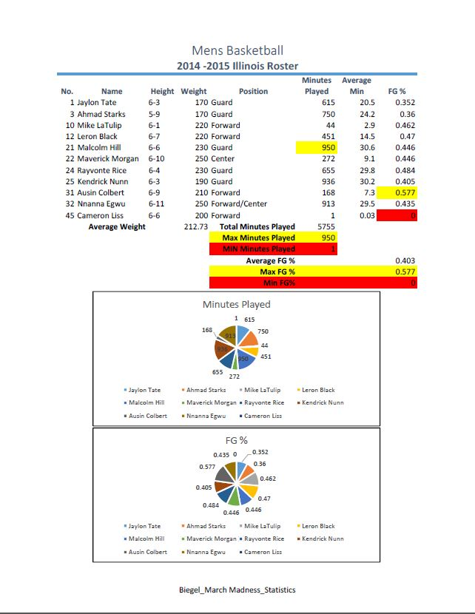
  - For each player include:
    - Jersey Number
    - First and Last Name
    - Height
    - Weight
    - Position
    - Minutes played during regular season
    - Average minutes per game during regular season
    - Field goal percentage during regular season

  - Then, using formulas, calculate the following:
    - Average weight of players
    - Average field goal percentage of players
    - Player with most minutes played
    - Player with least minutes played
    - Player with highest field goal percentage
    - Player with lowest field goal percentage

  - Lastly, use this information to create pie charts to show how player compare. Examples include minutes played or Field Goal Percentage (FG%). You will need to evaluate at least two criteria.

Sheet 2 – 2018-2019 Season Results By Player

  - For each player include
    - Jersey Number
    - First and Last Name
    - Position
    - Minutes played during the regular season
    - Field goals attempted during the regular season
    - Field goals made during the regular season
    - Three point shots attempted during the regular season
    - Three point shots made during the regular season
    - Fouls during the regular season

Sheet 3 - Tournament Game Results

  - Record your team’s stats for one tournament game. Include the following:
    - Date and time of the game
    - The teams that played
    - Location of the game
    - Who won or loss
    - Score for each team
    - A picture of each team’s mascot/logo
    - Which player had the highest points (both teams) for the game
    - Which player had the most rebounds (both teams) for the game
    - Team fouls (both teams) per game
    - Field goal percentage for the team
    - Free throw percentage for the team

  - Then determine who your MVP for the tournament is. Create charts showing his contributions (at least three) versus what the rest of the team contributed. For example his points scored as compared to the team as a whole.

