Instructions: Below is a list of computer hardware. Classify as either an Input Device, Output Device or Both. Use all words only once; but remember, not all blanks in the table below will be filled in.

Keyboard, Speakers, Mouse, Scanner, Microphone, Graphics Tablet, LaserJet Printer, Joystick, Web Cam, Biometric Devices, Monitor, Plotter, Inkjet Printer, Trackball, Touchpad, Digital Camera, Touch Screen, Projector (Hint: Only one is both an input and output device)
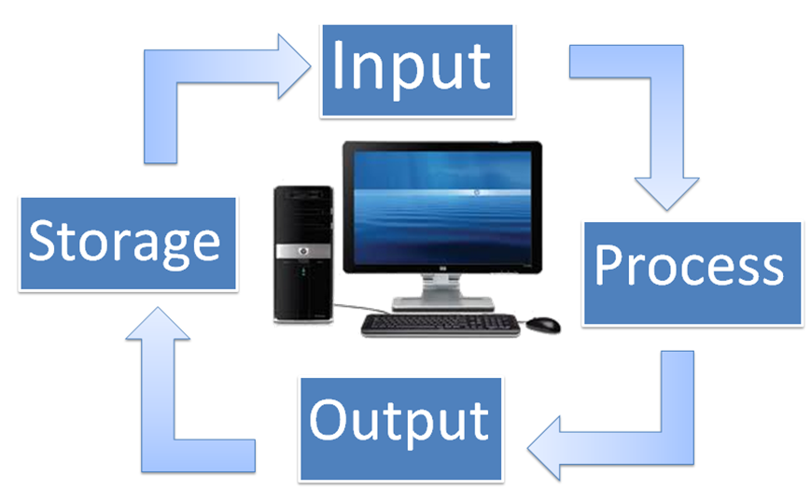

Input  Devices | Output  Devices | Both Input and Output Device

